C:\Users\JohnDT\AppData\Local\Microsoft\Windows\Temporary Internet Files\Content.IE5\ETFRVN1M\MC900240417[1].wmfC:\Users\JohnDT\AppData\Local\Microsoft\Windows\Temporary Internet Files\Content.IE5\8Y5V6DOQ\MC900217582[1].wmfBaltimore English Dart League

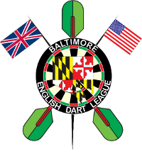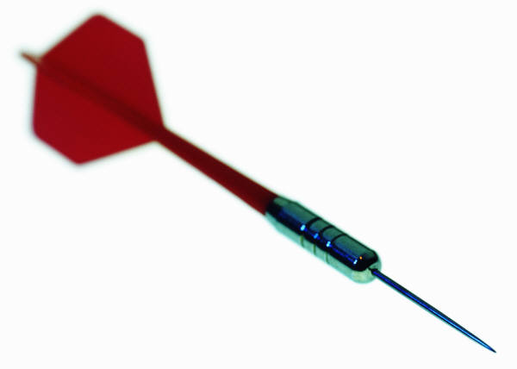

[www.BaltimoreEnglishDartLeague.com](http://www.BaltimoreEnglishDartLeague.com)

* *Looking For New and Veteran Shooters!*
* *Travel Team Style League*
* *We Shoot on Thursday’s @ 8:00*
* *We Shoot Cricket and 301 Games along with doubles matches*
* *We have two season’s fall and summer dates are TBA*
* *Coed teams, must have at least four members including one captain*
* *Some current teams may be available to join*.
* *We have Luck of the draws*! Win cash, Earn Trophy’s!

*Contact Wayne Grob our Commissioner by number on our site*

See our website for more information!!

* [www.BaltimoreEnglishDartLeague.com](http://www.BaltimoreEnglishDartLeague.com)